Policy and Disclaimer:
The Tuxedo Pet Lodge pledges to give appropriate care to all boarded pets. I will not hold the Tuxedo Pet Lodge responsible for conditions that often are unavoidable in boarding environments such as, but not limited to, weight loss, rough hair, cough, bloat, canine influenza and sudden death. In the event of an emergency, Tuxedo Pet Lodge will make all attempts to contact me, but I acknowledge that in the event that I am unreachable, the staff at the Tuxedo Pet Lodge is able to authorize appropriate treatment of my pet(s) until I am available to discuss further care and costs with the attending veterinarian.
I certify that my pet(s) appear to be free of contagious diseases, including external parasites and has/have not bitten anyone within the last 10 days. I certify that my pet is current on all required vaccinations and have provided written documentation of same.

In the event that your pet bites or injures another pet or person, the owner assumes all legal and financial responsibilities. While your pet(s) is/are staying with us, he or she may come into contact with other pets, depending on the your request while your pet is boarding at our facility. You acknowledge and agree that in the unlikely event that your pet is injured by another pet, you will not hold us responsible for the injury.

It is understood that the owner is responsible for all damages incurred by your pet during his or her stay. These damages include (but are not limited to) destruction of kennels or walls. If your pet demonstrates aggressive behavior or is known to scratch or chew or otherwise cause damage, it should be stated so that precautions can be taken.

I understand that if I fail to pick up my pet(s) within 10 days of notification to the above individual, my pet(s) will be considered abandoned and will be handled in accordance with the New York State Law and that doing so does not relieve me of my financial obligations.

I understand that check out time is 8:30 am to 10:30 am and 4:30 pm to 6:30pm, 7 days a week.
I understand that I will be charged for the day of entry regardless of time of entry.
Pets checked out after 9:00AM will be charged for that day.
All cancellations must be made 48 hours in advance or you will be subject to a late cancellation fee.
This agreement applies to all visits by your pet to the Tuxedo Pet Lodge.

I have read the above agreement entirely and I am in full agreement.
Customer Signature _______________________________ Date: ______________________
Printed Name: ______________________________________ Date: ____________________
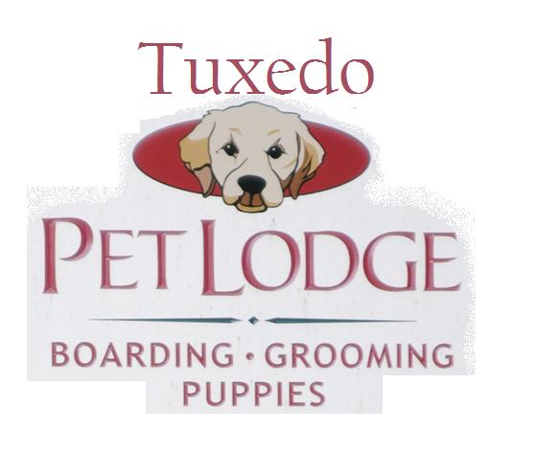
20 Nolan’s Way, Southfields, NY | cathy@tuxedopetlodge.com | Phone: 845-351-3395 | Fax: 845-712-5493

At the Tuxedo Pet Lodge, when we board your dog, we ensure that they are comfortable and enjoy their time here. It is important to us that the dogs are relaxed and confident and we make it a point that their stay is a pleasurable experience. Each pet vacation is tailored to meet your pet’s individual needs.
Please bring the appropriate amount of food for your pets stay in d-i-s-p-o-s-a-b-l-e zip lock bags or containers, clearly marked with their name. If you choose to bring your pets bowls, please mark the bottom of the bowls with duck tape clearly marked with their name.
Every pet is inspected for fleas and ticks upon arrival. If a problem is found, we will bath your pet in flea and tick shampoo for everyone’s protection. An additional fee will be charged for this service.
We are not responsible for destroyed beds or belongings during your pets stay.
Although not presently a requirement, I also understand that the Tuxedo Pet Lodge strongly recommends that all dogs be vaccinated against canine influenza.

Owner Information

Name: _____________________

Address: ___________________

City: ______________________

State: ______ Zip: ________

Date: _____________

Email: _____________________

Home #:____________________

Cell #:_____________________

Emergency Contact

Name: _______________________

Phone #: _____________________

Relation: ___________________
Veterinarian Information

Name: ____________________________

Address: __________________________

Phone #: __________________________

Pet Information
Name: _____________________

Sex: ___________________

Age: ______________________

Weight: _____________

Breed: _____________________

Neut/Spayed? : ______

Pet Personality Profile
Medicine/Supplement Instructions

Name: ______________

Dosage: _____________

Instructions: ________________________________________________________________________________

Feeding Instructions

Brand: __________________

Amount: _________________

Frequency: _______________

